Mi Home Dishwash Round Bar (500g)
MRP
₹88.00

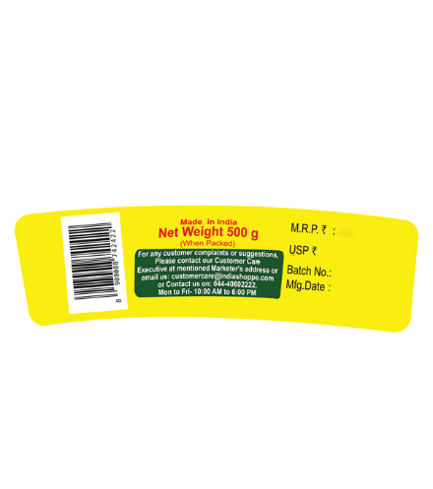
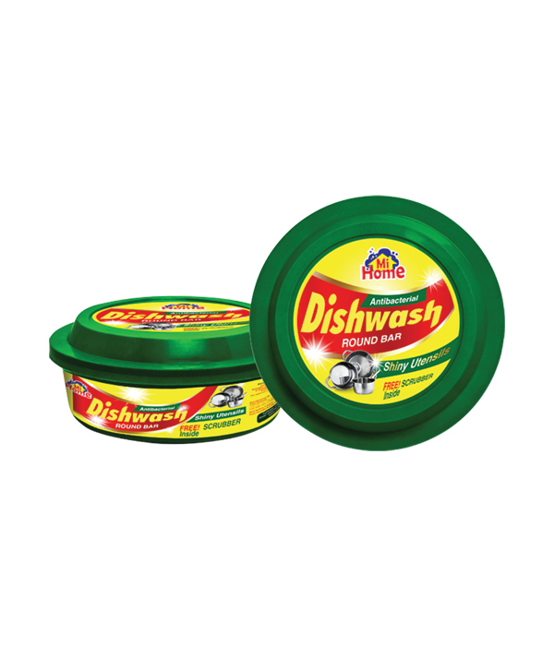

Product Description:
Slow-Dissolving Dish Wash bar has a special polymer that prevents the formation of white film on washed dishes. The product is specially designed to minimise wastage while providing total cleaning of your dishes.

Net Content: 500g
Directions for use: Take a small amount of bar on a wet sponge or dish wash cloth. Wet the dish and rub the sponge or dishcloth directly on the dish to create lather. Wash and rinse thoroughly. Use as needed to wash dishes. Keep the bar dry between uses to extend its lifespan. For external use only.

Storage: Store in a cool, dry place away from sunlight and children.

Manufactured by: Kanani Industries, Survey No .- 183/1/P, Besides Ashapura Agro Ind.,Near Canal, Bavla-Sanand Road, At - Lodariyal, Dist .- Ahmedabad-382 213 (Gujarat)

Marketed by: Mi Lifestyle Marketing Global Private Limited, No.25, G.N. Chetty Road, T. Nagar, Chennai - 600017, Tamil Nadu.

Shelf Life: Use before 24 months from the date of manufacture.

Additional Information: Mi Home Antibacterial Dishwash Round Bar is a solid dishwashing product designed to effectively clean dishes while being gentle on hands. It contains antibacterial agents that help eliminate germs and bacteria commonly found on dishes. This product typically has a mild, pleasant fragrance, though specific scents may vary product to product.
Used for: Manual dishwashing. Suitable for most types of dishes and cookware.
Benefits: Gentle on hands while being tough on grease and stains. Packaging may be recyclable or made from recycled materials, which can indirectly help reduce environmental impact.

Mi Home Glass Cleaner (500ml)
MRP
₹93.00
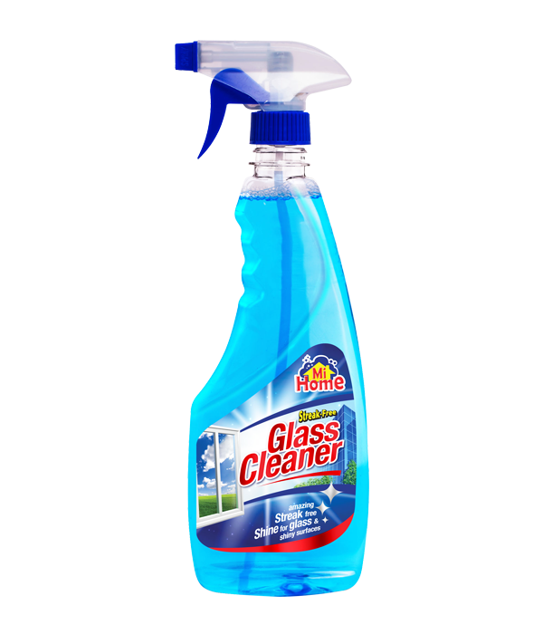

Product Description
Mi Home Streak-free Glass Cleaner is dosed with a high degree of solvent. One of the problems with ordinary glass cleaners is the presence of streaks after cleaning. This wonderful product provides streak-free cleaning, keeping your glass & shiny surfaces dry and clean within minutes after use.
Net Content: 500Ml

Directions for use: Press pump to spray on the surface and wipe with clean and dry cotton cloth.

Ingredients: IPA, Non Ionic Surfactant, CI No. 42090, Perfume, DM Water.

Storage: IPA, Non Ionic Surfactant, CI No. 42090, Perfume, DM Water.

Manufactured by: Skyline Herbals Private Limited. No. 10, Mahagujarat Estate, Moraiya, Ta Sanand, Ahmedabad - 382213. Mfg Lic No Gc/1474.

Marketed by: Mi Lifestyle Marketing Global Private Limited No.25, G.N. Chetty Road, T. Nagar, Chennai - 600017, Tamil Nadu.

Shelf Life: Use before 24 months from the date of manufacture.

Additional Information: Our glass cleaner is designed to deliver a streak-free shine on all your glass surfaces. Perfect for mirrors, TVs, car windows, and more, it effortlessly removes fingerprints, smudges, and dirt. Enjoy a crystal-clear finish and a spotless view with every use.
Used for: Cleaning various types of glass surfaces, including mirrors, TVs, car windows.
Benefits: Streak-Free Shine: Delivers a clear, streak-free finish on glass, mirrors, and screens. Versatile Use: Ideal for a variety of surfaces including windows, TV screens, and car windows. Effortless Cleaning: Quickly removes smudges, fingerprints, and dirt with minimal effort.
Disclaimers: In case of accidental contact with eyes, skin, wash well with water and seek medical advice immediately and show the container to the doctor. Do not swallow.

Mi Home Toilet Cleaner (500ml)
MRP
₹110.00
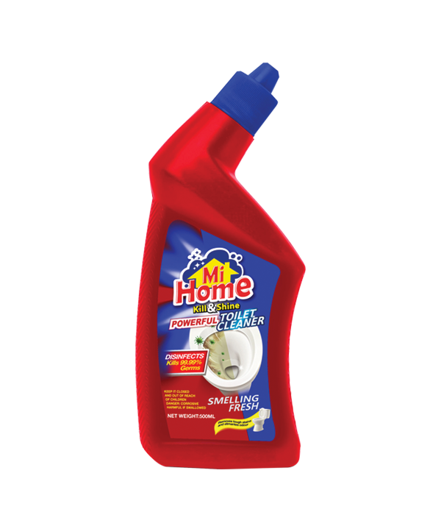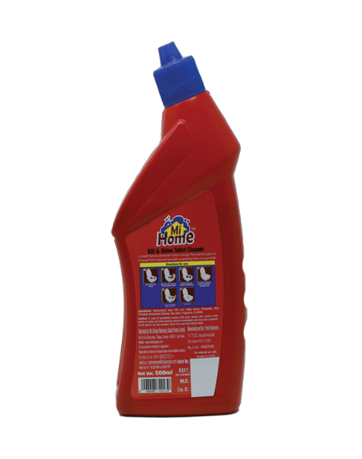

Product description:
Kill & Shine Toilet Cleaner is made from an advanced "colour change" formula that gets rid of tough lime scale and provides a sparkling shine to your toilet.
Net Content: 500ml

Directions for use: Shake the bottle before use. Apply directly under the rim and on the sides of the toilet bowl. Let it sit for at least 10 minutes before scrubbing with a toilet brush. Flush after cleaning. Use as needed for maintaining a clean and hygienic toilet.

Ingredients: Hydrochloric Acid 13% w/v, Oleyl Amine Ethoxylate, Alkyl Trimethyl Ammonium Chloride, Butylated Hydroxy Toluene, DM Water, Fragrance, C.I. No. 42090

Storage: Store in a cool, dry place away from sunlight and heated sources. Keep out of reach of children and pets.

Manufactured by: Palmer Laboratories Private Limited, 167, 1st floor, Mahagujarat Estate, Moraiya, Ta. - Sanand, Dist. - Ahmedabad - 382 213. Drug. Lic. No. : G/25/1742

Marketed by: Mi Lifestyle Marketing Global Private Limited No.25, G.N. Chetty Road, T. Nagar, Chennai - 600017, Tamil Nadu.

Shelf Life: Mi Lifestyle Marketing Global Private Limited No.25, G.N. Chetty Road, T. Nagar, Chennai - 600017, Tamil Nadu.

Additional Information:
Kill & Shine Powerful Toilet Cleaner is designed to effectively clean and disinfect toilets, remove tough stains and leave a fresh fragrance.
Used for: Cleaning and disinfecting toilet bowls, removing tough stains, germs, and odors.
Benefits: Contains powerful cleaning agents and disinfectants for thorough cleaning, along with a fresh fragrance.
Mi Home Liquid Laundry Detergent (500ml) MRP
₹242.00

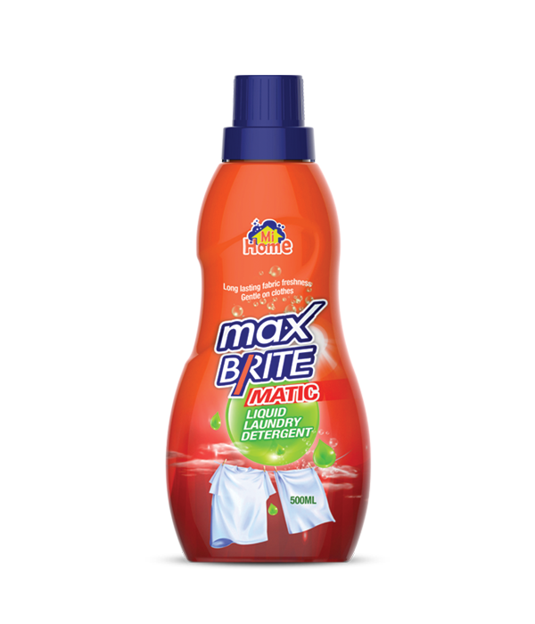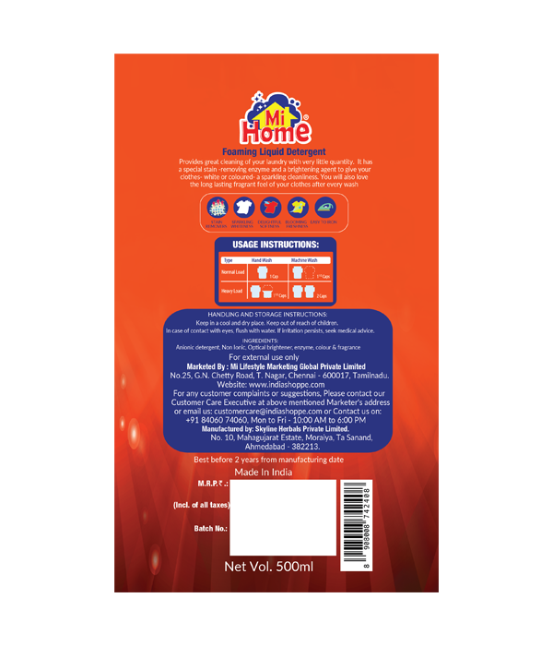

Product Description:
Foaming liquid detergent provides great cleaning of your laundry with very little quantity. It has a special stain -removing enzyme and a brightening agent to give your clothes- white or coloured- a sparkling cleanliness. You will also love the long lasting fragrant feel of your clothes after every wash.
Net Content: 500ml

Directions for use: Use one capful per load for regular washing cycles; for heavily soiled clothes, use two capfuls.

Ingredients: Anionic detergent, Non Ionic Optical brightener, enzyme, colour & fragrance.

Storage: Store in the original container in a cool, dry place away from sunlight. Keep out of reach of children.

Manufactured by: Skyline Herbals Private Limited. No. 10, Mahagujarat Estate, Moraiya, Ta Sanand, Ahmedabad - 382213.Mfg Lic No Gc/1474.

Marketed by: Mi Lifestyle Marketing Global Private Limited, No.25, G.N. Chetty Road, T. Nagar, Chennai - 600017, Tamil Nadu.

Shelf Life: Use before 24 months from the date of manufacture.

Additional Information: Mi Home Max Brite Matic Liquid Laundry Detergent is designed for modern households seeking superior cleaning performance combined with environmental responsibility. This detergent is formulated to deliver exceptional cleaning power, removing tough stains and leaving clothes fresh and bright. Suitable for both front and top load washing machines, Max Brite Matic ensures optimal results with every wash.
Used for: Cleaning all types of fabrics, including delicate garments.
Benefits: Formulated with an advanced enzyme-based formula for effective stain removal. Safe for use with septic systems and all water temperatures. The concentrated formula reduces the amount needed per wash, leading to fewer plastic bottles being used and disposed of.

Mi Home Floor Cleaner (500ml)
₹132.00

Product Description:
This disinfectant floor cleaner is formulated to effectively clean and disinfect various types of flooring surfaces, including tiles, wood, laminate, and linoleum. It combines cleaning agents with disinfecting properties to provide a thorough and hygienic cleaning experience. The formulation ensures that it not only removes dirt and grime but also kills a broad spectrum of germs and bacteria, leaving surfaces sanitized.

Net Content: 500ml
Directions for use: Floors, Bathrooms & Tiles: Use one capful in half a bucket of water (4 Litres). Gently mop the surface.
Kitchen Surface: Apply undiluted on dirty area. Leave for 10 minutes and rinse.

Ingredients: Benzalkonium Chloride Solution (50%) - 4 % W/v, Excipients, DM Water, Perfume, CI No. 14720

Storage: Store in a cool, dry place away from children and pets. Dispose of according to local regulations. Keep out of reach of children.

Manufactured by: Palmer Laboratories Private Limited, 167, 1st floor, Mahagujarat Estate, Moraiya, Ta. - Sanand, Dist. - Ahmedabad - 382 213. Drug. Lic. No. : G/25/1742

Marketed by: Mi Lifestyle Marketing Global Private Limited, No.25, G.N. Chetty Road, T. Nagar, Chennai - 600017, Tamil Nadu.

Shelf Life: Use before 24 months from the date of manufacture.

Additional Information: This disinfectant floor cleaner is formulated to effectively clean and disinfect various types of flooring surfaces, including tiles, wood, laminate, and linoleum. It combines cleaning agents with disinfecting properties to provide a thorough and hygienic cleaning experience. The formulation ensures that it not only removes dirt and grime but also kills a broad spectrum of germs and bacteria, leaving surfaces sanitized.
Used for: Cleaning and disinfecting various types of flooring surfaces, including tiles, wood, laminate, and linoleum.
Benefits: Combines potent cleaning agents with disinfecting properties. Safe for use on multiple floor types and does not damage surfaces when used as directed.

